**PRIMALITY CHECK IN MIPS**

**LAB # 05**



**Fall 2023**

**CSE-304L Computer Organization and Architecture Lab**

Submitted by: **Ali Asghar**

Registration No.: **21PWCSE2059**

Class Section: **C**

“On my honor, as student of University of Engineering and Technology, I have neither given nor received unauthorized assistance on this academic work.”

Submitted to:

**Dr. Bilal Habib**

Date:

**2nd November 2023**

**Department of Computer Systems Engineering**

**University of Engineering and Technology, Peshawar**

**ASSESSMENT RUBRICS COA LABS**

|  |  |  |  |  |
| --- | --- | --- | --- | --- |
| **LAB REPORT ASSESSMENT** | | | | |
| **Criteria** | **Excellent** | **Average** | **Nill** | **Marks Obtained** |
| 1. **Objectives of Lab** | All objectives of lab are properly covered  [Marks 10] | Objectives of lab are partially covered  [Marks 5] | Objectives of lab are not shown  [Marks 0] |  |
| 1. **MIPS instructions with**   **Comments and proper indentations.** | All the instructions are well written with comments explaining the code and properly indented  [Marks 20] | Some instructions are missing are poorly commented code  [Marks 10] | The instructions are not properly written  [Marks 0] |  |
| 1. **Simulation run without error and warnings** | The code is running in the simulator without any error and warnings  [Marks 10] | The code is running but with some warnings or errors.  [Marks 5] | The code is written but not running due to errors  [Marks 0] |  |
| 1. **Procedure** | All the instructions are written with proper procedure  [Marks 20] | Some steps are missing  [Marks 10] | steps are totally missing  [Marks 0] |  |
| 1. **OUTPUT** | Proper output of the code written in assembly  [Marks 20] | Some of the outputs are missing  [Marks 10] | No or wrong output  [Marks 0] |  |
| 1. **Conclusion** | Conclusion about the lab is shown and written  [Marks 20] | Conclusion about the lab is partially shown  [Marks 10] | Conclusion about the lab is not shown[Marks0]  [Marks 0] |  |
| 1. **Cheating** |  |  | Any kind of cheating will lead to 0 Marks |  |
| Total Marks Obtained:__________  Instructor Signature: ______________________ | | | | |

**Task 1:**

Write a program to check whether a number input by user is prime or not.

**Code:**

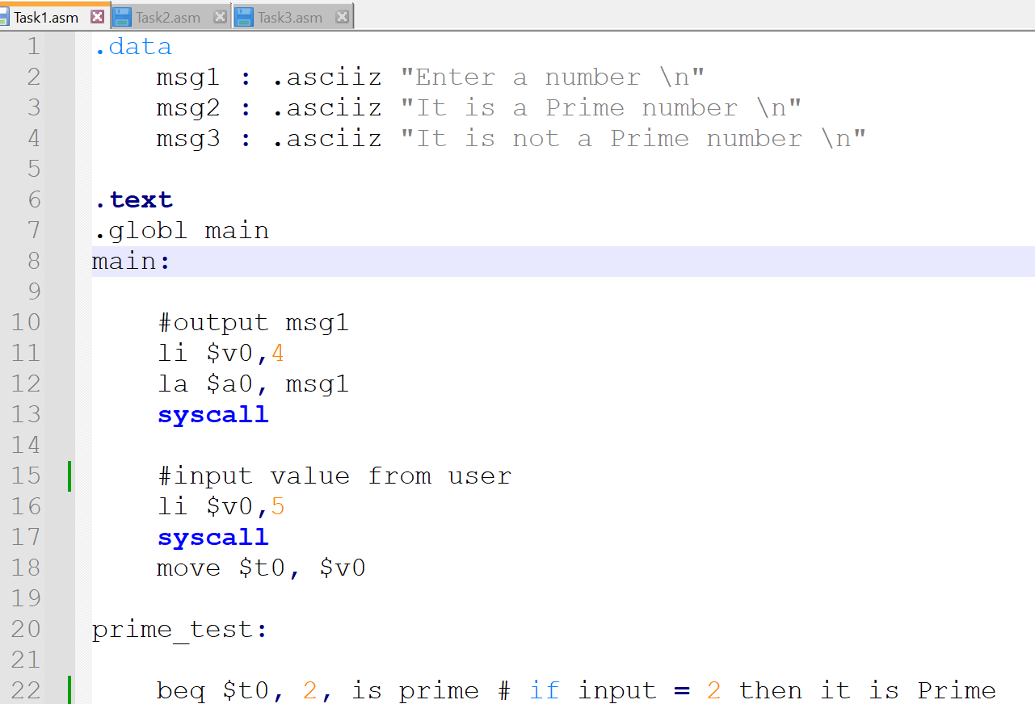

**Output:**

**Task 2:**

Repeat the above problem and display the largest two prime numbers lower than itself. Hint: If a user enters 20, then program displays 19 and 17.

**Code:**

**Output:**

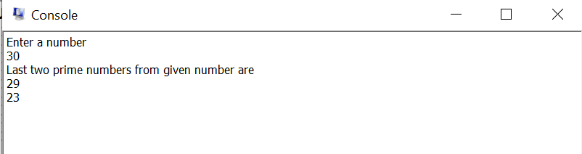

**Task 3:**

Write a program which takes two limits from user and display prime numbers between the two limits (if user enter lower limit 10 and upper limit 30 then display prime numbers between 10 and 30).

**Code:**

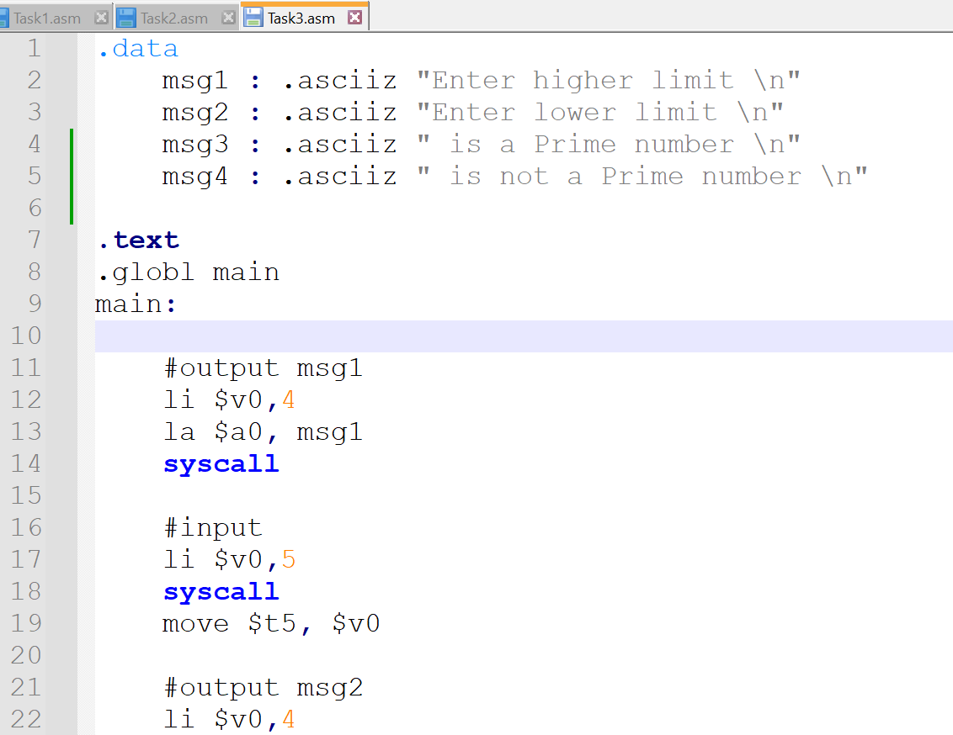

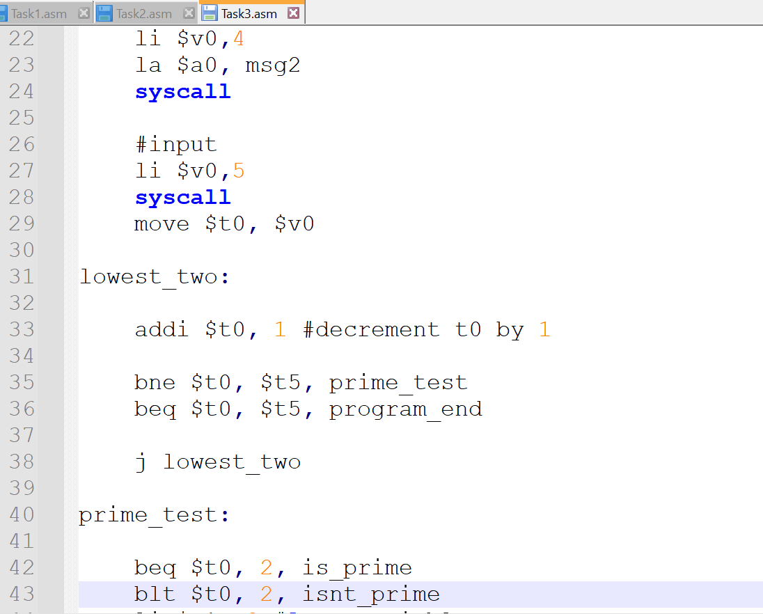

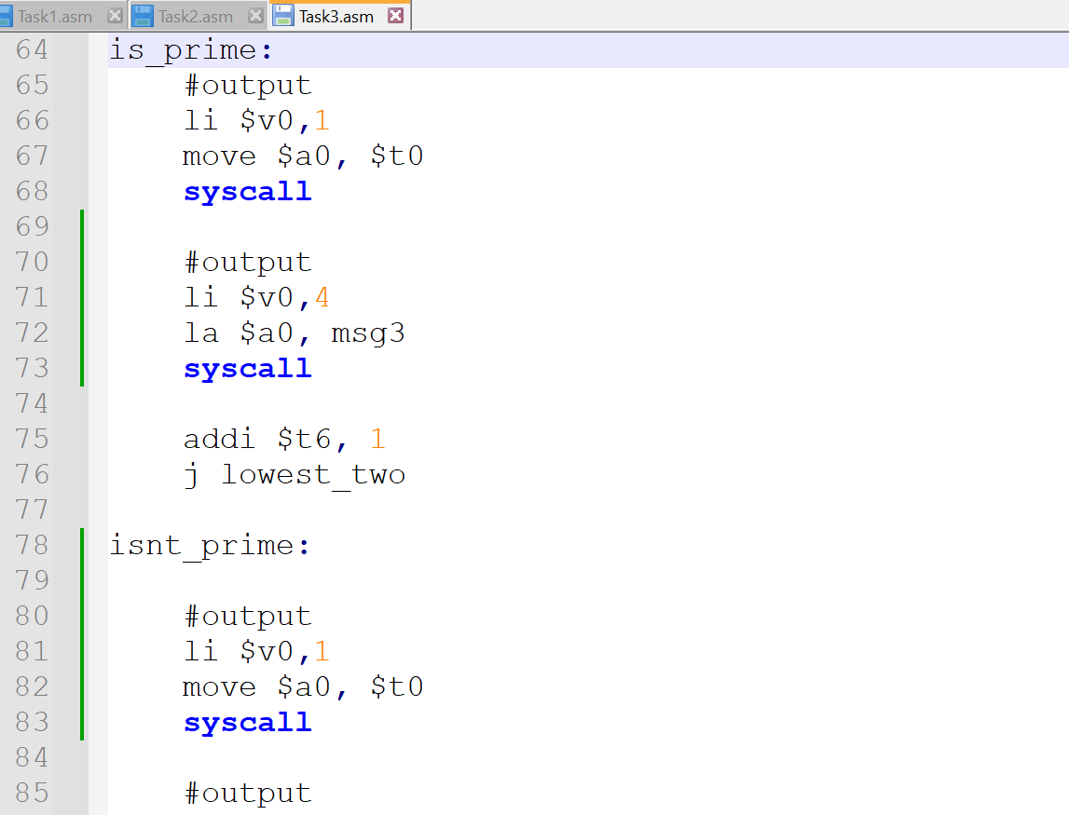

**Output:**

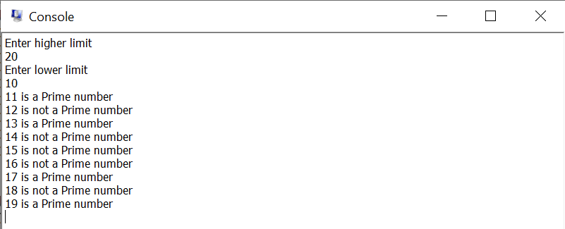

**Conclusion:**

In this lab, I learned about primality check (checking prime numbers) in MIPS Assembly.